A000-Am,S-Peru-Nazca-Vessel-Feline Wind God-Polychrome Ceramic-400 CE

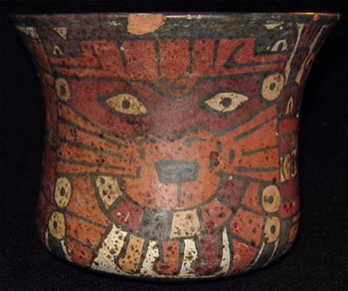    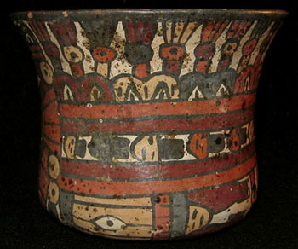    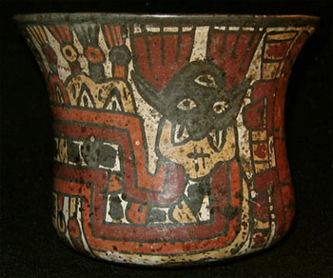

Am,S-Peru-Nazca-Vessel-Feline Wind God-Polychrome Ceramic-400 CE

Case No.: 10

**Accession No.**

**Formal Label:** Am,S-Peru-Nazca-Vessel-Feline Wind God-Polychrome Ceramic-400 CE

**Display Description:**

Lovely Nazca polychrome bowl, featuring the  mythological wind god with feline attributes  flying along the vessel, wearing a tunic and large cloak with trophy heads  attached, painted in reddish brown, orange,  white, cream, gray and black.

**LC Classification:**

**Date or Time Horizon:**

**Geographical Area:** South Coast - Peru

**Map:**

**GPS coordinates:**

**Cultural Affiliation: Nazca**

**Media: Polychrome ceramic**

**Dimensions:** 4" (10 cm) Height, 5" (12.7 cm) Diameter

**Weight:**

**Condition: Original.** Excellent  condition, intact, with only a small chip on the rim

**Provenance:** Private Collection

**Discussion:**

**References:**